Steps to Install and Configure Rhapsody Route for Bulk Import of NEW Providers and Organizations into NBS

NOTE: Kindly take a backup of your Test environment before proceeding to the steps below so that a roll back can be attempted in case there is any issue
The Rhapsody route is only for provider and organization data. Also, this is only for providers
and organizations that do not already exist in the system (because currently there is no way for Rhapsody to compare with data that is already in the system). States will need to work with their Rhapsody person to load the route in the Test environment. Once the route is loaded ensure that the route is stopped. After this, follow the steps outlined below to configure the Rhapsody route for bulk-import of organizations/providers:

- Make sure the correct Database information is set up in the Rhapsody Variables Manager (View
→ Rhapsody Variables Manager):
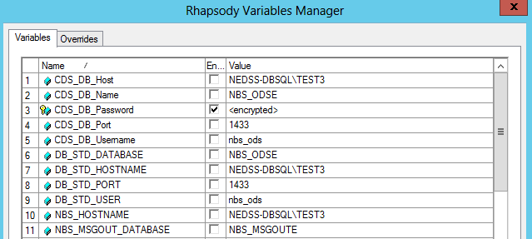

- Define the folders where you will drop the file using the following variables (scroll down on the list above to see these variables)

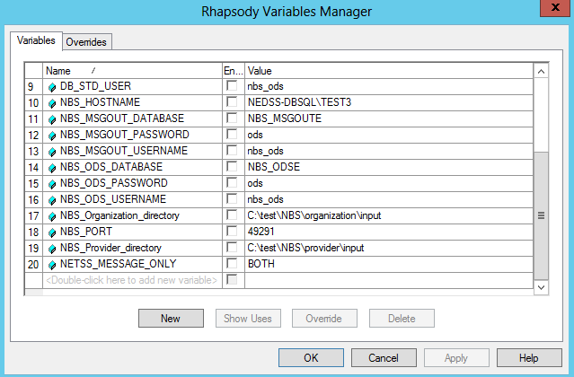

- Run the following query and look for the class_nm_cd as your state code (eg: AL, GA, TN etc) in this table:
select * from nbs_odse..Local_UID_generator
If your find this value in there, you do not need to do anything, if it this value is not there in the
local_uid_generator table then please reach out to me as we would need to further investigate
this
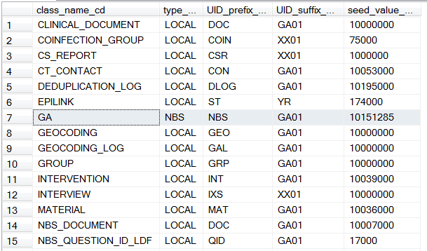
- The Rhapsody route will need to be configured with this state code from the previous step. In the Rhapsody route double click on the NBS_ODSE route and double click on the ‘Set stateCode’ property:
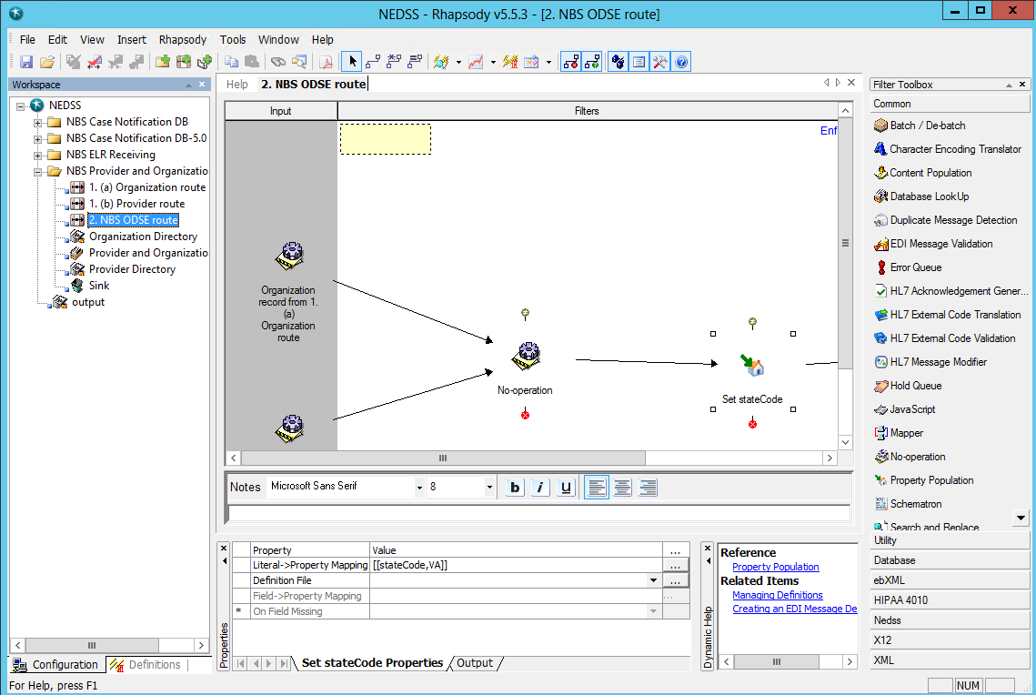

This will bring up a popup property window which can then be opened to change the state code to your state’s state code:
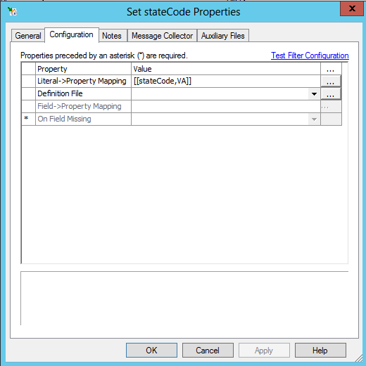
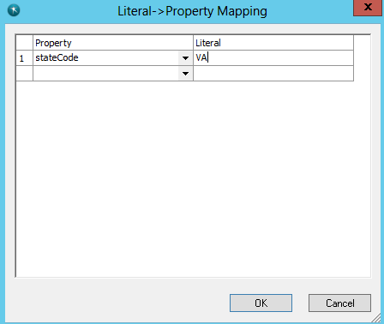
- Take a count of the following tables before starting the Rhapsody route. And then once the
Rhapsody route is turned on, wait a few minutes and re-run these queries to see the new counts
(this will tell you what table counts changed)
select count(*) from nbs_odse..Entity
select count(*) from nbs_odse..Entity_id
select count(*) from nbs_odse..Person
select count(*) from nbs_odse..Person_name
select count(*) from nbs_odse..Organization
select count(*) from nbs_odse..Organization_name
select count(*) from nbs_odse..Entity_locator_participation
select count(*) from nbs_odse..Postal_locator
select count(*) from nbs_odse..Tele_locator
select count(*) from nbs_odse..Role

- Remove all unwanted (empty/highlighted/non-state data) rows from the Excel workbook you
shared and save the file as an MS-DOS .csv file :

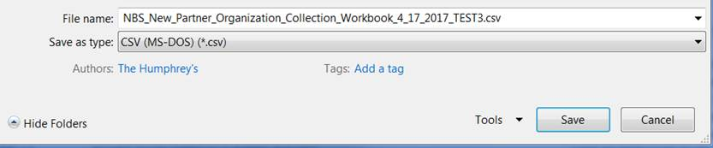

- Drop this newly saved .csv file in the directory specified in the NBS_Organization_directory
variable on step #2 above

- Once all the steps above are complete, start the Rhapsody route and wait a few minutes for the
Rhapsody to process (you can confirm that all the rows in the Excel workbook has been processed successfully by going to Rhapsody Management Console → Communication Points → Provider and Organization insert (the highlighted number below will show the number of rows processed from the excel file):
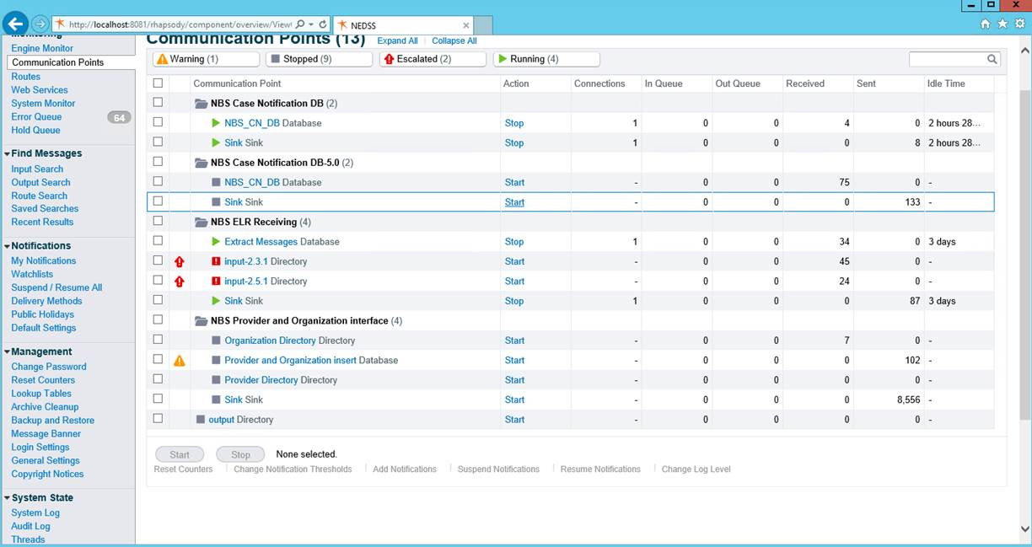
- Check the counts for the organization table and make sure the table counts have gone up by the
same number as above (counts should be the same for both the queries below):
select count(*) from nbs_odse..Organization
select count(*) from nbs_odse..Organization_name

Similarly check other tables to make sure data looks correct. Once this is done, users can go to the front end and validate the data imported in. Please reach out to the NBS Support team for any questions/concerns

